Lab Assignment 1

Chaudhary Hamdan

1905387

Date: 12-01-2022

Question:

In the dataset “data.csv”, in google classroom:

Code:

"""

Created on Wed Jan 12 12:12:21 2022

@author: Chaudhary Hamdan

"""

import pandas as pd

df = pd.read_csv("Data.csv")

print(df)

Output:

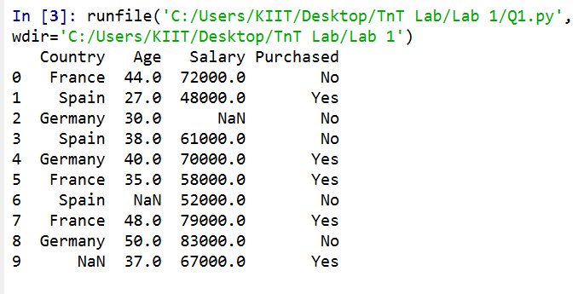

i) Add a new column : Salary_class

A for loop is implemented and the observations are

separated into three categories:

o Salary

• greater than 70000 - class0

• between 61000-70000 -class1

• between 48000-60000 -class2

• The classes have been stored in a new column ‘Salary Class’

Code:

"""

Created on Wed Jan 12 12:12:21 2022

@author: Chaudhary Hamdan

"""

import pandas as pd

df = pd.read_csv("Data.csv")

sal_class = []

for i in range(10):

sal = df['Salary'][i]

if sal>70000:

sal_class.append('class0')

elif sal>=61000:

sal_class.append('class1')

elif sal >= 48000:

sal_class.append('class2')

else:

sal_class.append('')

df['Salary_class'] = sal_class

print(df)

Output:

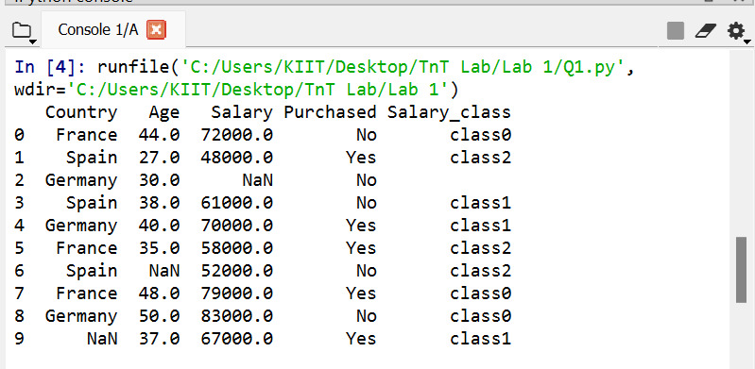

ii) Implement above using both for and while loop

Code:

"""

Created on Wed Jan 12 12:12:21 2022

@author: Chaudhary Hamdan

"""

import pandas as pd

df = pd.read_csv("Data.csv")

sal_class = []

i = 0

while i < 10:

sal = df['Salary'][i]

if sal>70000:

sal_class.append('class0')

elif sal>=61000:

sal_class.append('class1')

elif sal >= 48000:

sal_class.append('class2')

else:

sal_class.append('')

i += 1

df['Salary_class'] = sal_class

print(df)

Output:

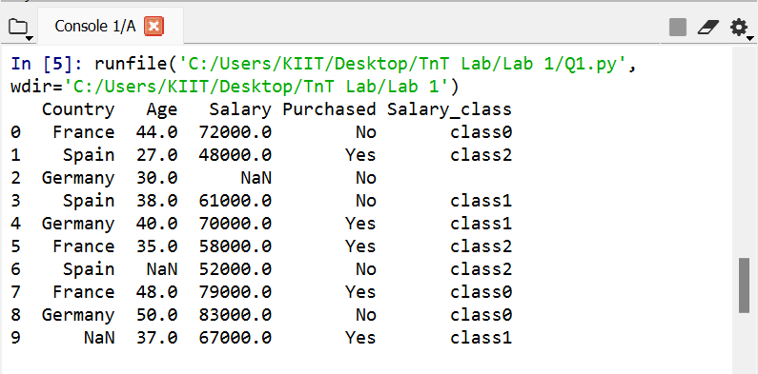

iii) Count the number of each class (class 0, class1,class2) in your

dataset.

Code:

"""

Created on Wed Jan 12 12:12:21 2022

@author: Chaudhary Hamdan

"""

import pandas as pd

df = pd.read_csv("Data.csv")

sal_class = []

i = 0

while i < 10:

sal = df['Salary'][i]

if sal>70000:

sal_class.append('class0')

elif sal>=61000:

sal_class.append('class1')

elif sal >= 48000:

sal_class.append('class2')

else:

sal_class.append('')

i += 1

df['Salary_class'] = sal_class

c0 = len(df[df['Salary_class'] == 'class0'])

c1 = len(df[df['Salary_class'] == 'class1'])

c2 = len(df[df['Salary_class'] == 'class2'])

print(f'class0 = {c0}, class1 = {c1}, class2 = {c2}')

Output:

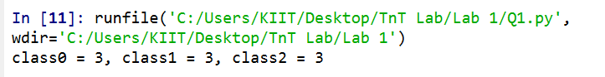

iv) Insert a new column Age_Converted:

Use function c_convert to add in the new column the converted values

fromcolumn “Age” :

dataset[“Age_Converted”]=dataset[“Age”]*12

Code:

"""

Created on Wed Jan 12 12:12:21 2022

@author: Chaudhary Hamdan

"""

import pandas as pd

df = pd.read_csv("Data.csv")

sal_class = []

i = 0

while i < 10:

sal = df['Salary'][i]

if sal>70000:

sal_class.append('class0')

elif sal>=61000:

sal_class.append('class1')

elif sal >= 48000:

sal_class.append('class2')

else:

sal_class.append('')

i += 1

df['Salary_class'] = sal_class

age_con = df['Age']*12

df['Age_Converted'] = age_con

print(df)

Output:

